**Lab 2**

**10 points**

1. **Using SQL*Plus show all the tablespaces and the locations of their associated datafiles. (Attach a screen shot.)**

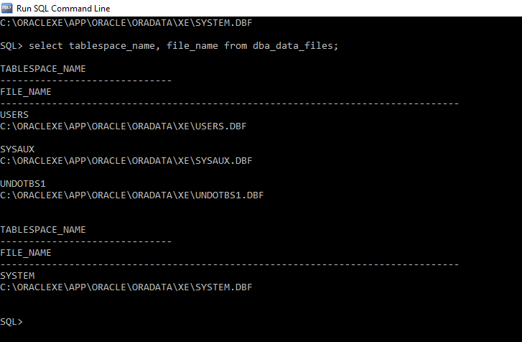

1. **Using SQL*Plus, run a query that will display the database name and date created. (HINT: use v$database) (Attach a screen shot).**

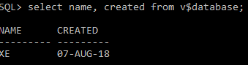

1. **Using Oracle 11g, create a new workspace and load the PLAYERS script file. After doing so, run a query that will list all the tables that are owned by the current user or in the current schema.** 
   1. **select * from all_tables**

**where owner = ‘KXC170030’;**

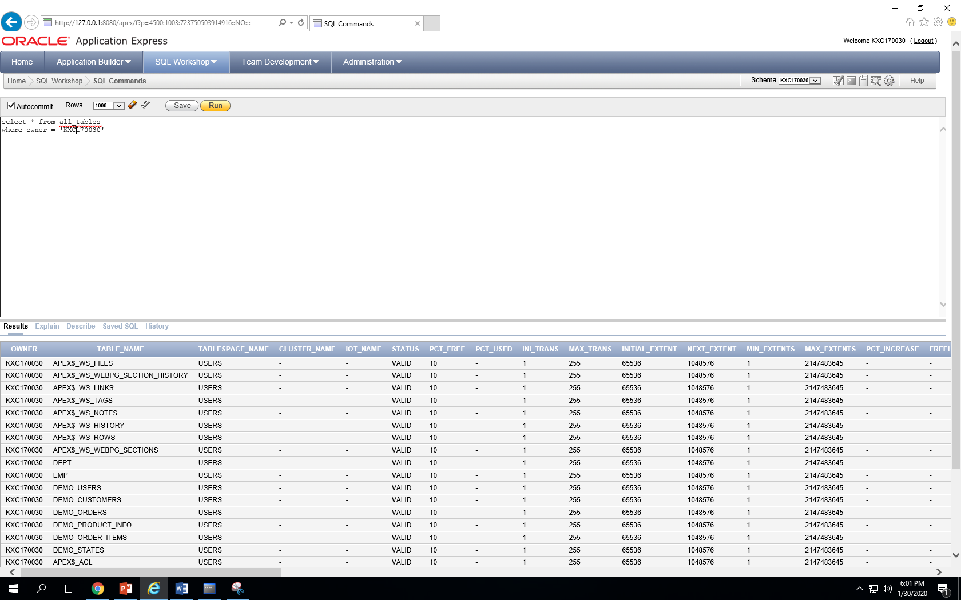

1. **You want to know what objects exist in your schema, specifically are there any stored procedures. Show all the unique types of objects (object_type) in the schema using one of the catalog tables. (Write the SQL statement here and attach a screen shot.) Modify the query to show all the objects in the database, not just at the schema level.** 
   1. **select distinct object_type**

**from user_objects**

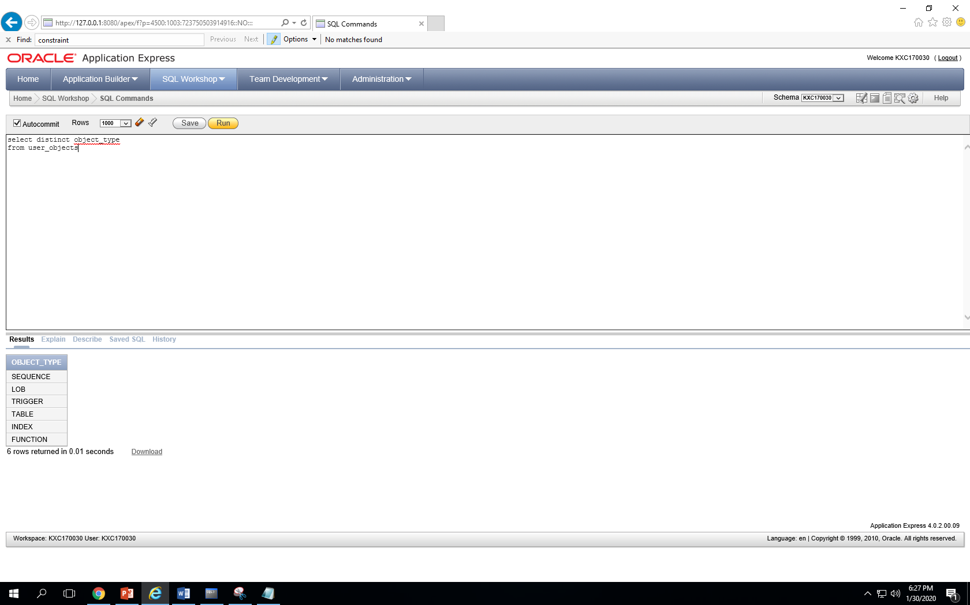

1. **How many rows are there in the PLAYERS table? Use 2 different queries to find the number of rows (one query should reference a system catalog table).**

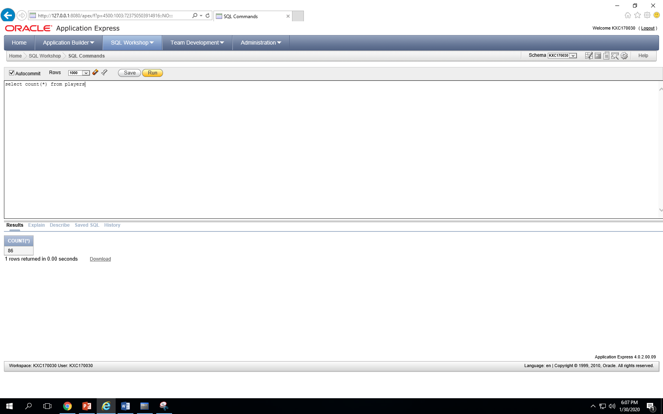

* 1. **86 rows**
  2. **select count(*) from players**
  3. **analyze table players compute statistics**
  4. **select table_name, num_rows from user_tables**

**where table_name = 'PLAYERS'**

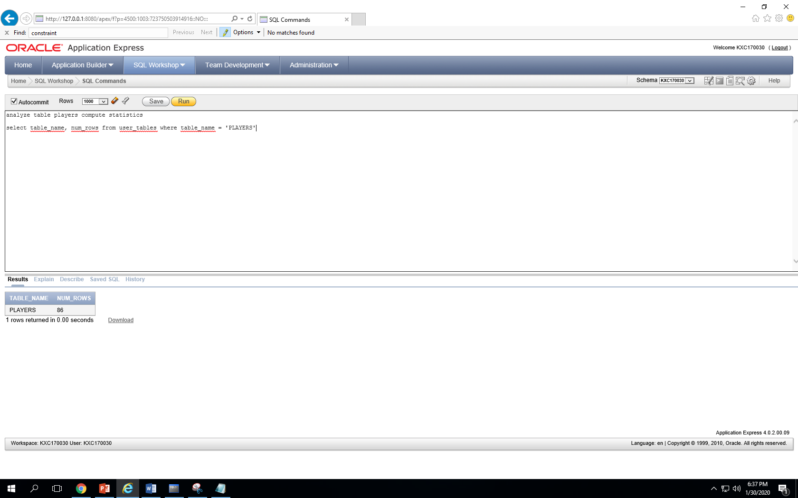

1. **Modify the TEAM table, remove the NOT NULL constraint on the state column. (HINT: you will need to first find the name of the constraint before you can remove the constraint. )**
   1. **select * from all_constraints**

**where table_name like '%TEAM%'**

* 1. **alter table teams**

**drop constraint TEAM_STATE_NN**

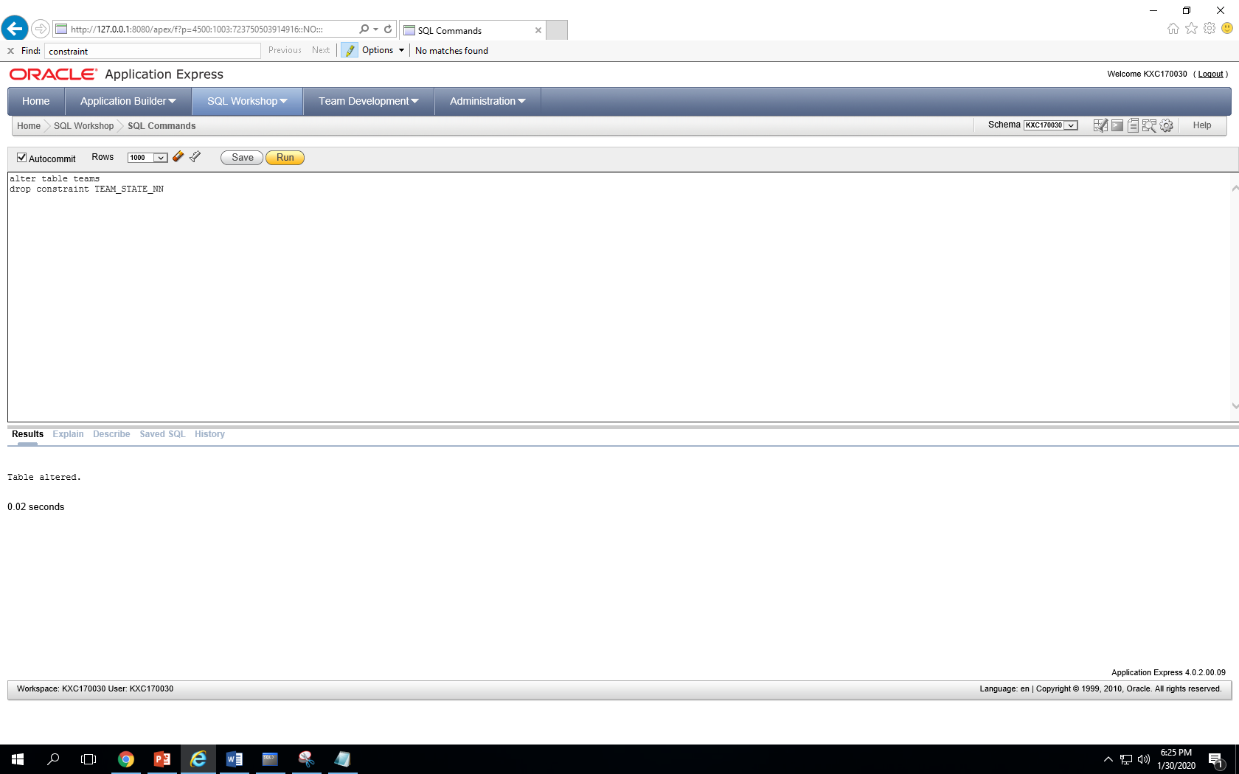

1. **Modify the PLAYERS table, change the ID column from a limit of 3 to a limit of 5.**

**alter table players**

**modify column id number(3, 5)**

1. **RENAME the TEAMS table to WS_TEAMS2014 and add a COMMENT to the table to indicate “Teams are World Series teams from 2014”.**
2. **For each player, list the player first name, player last name, jersey, and team name.**

**select fname, lname, jersey, name**

**from players p, teams t**

**where p.team_id = t.id**

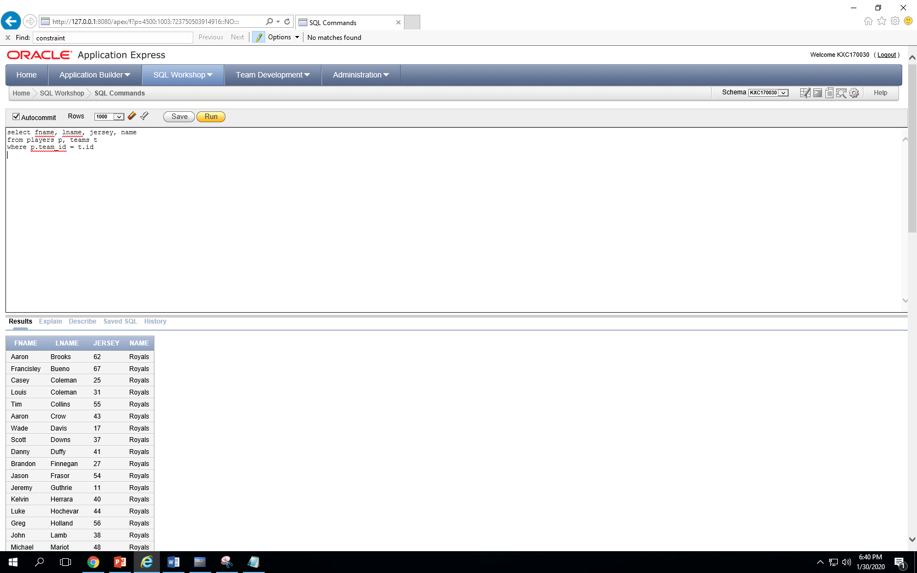

1. **List all the players who weigh between 160 and 200 pounds. List the player first name, player last name, weight, and team name. Write this query in 2 different ways (there are different ways you can filter the rows). Order by team name and then weight.** 
   1. **select fname, lname, weight, name**
   2. **from players p, teams t**
   3. **where p.team_id = t.id**
   4. **and weight between 160 and 200**
   5. **order by name**

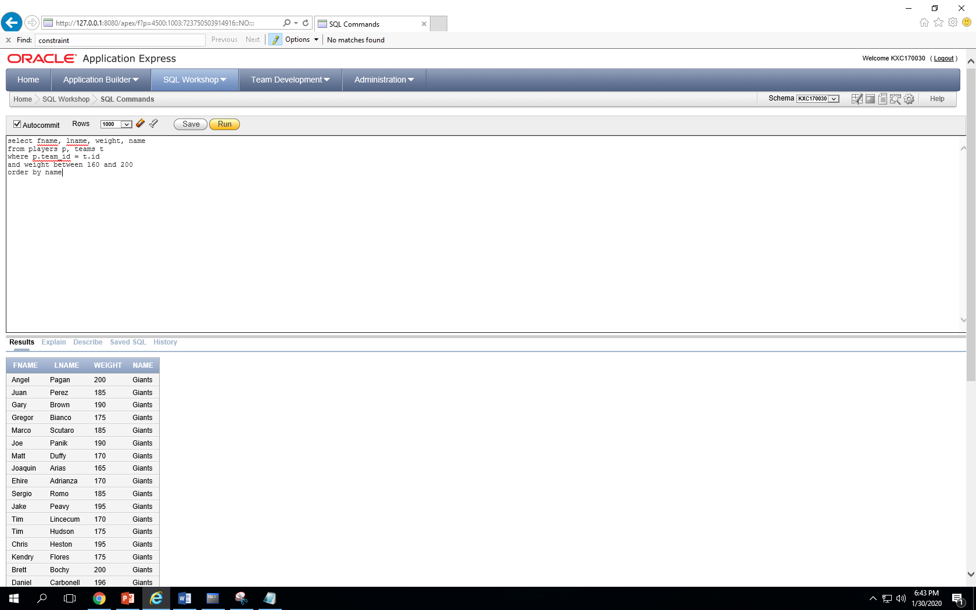

select fname, lname, weight, name

from players p, teams t

where p.team_id = t.id

and weight between 160 and 200

order by weight

